# Embedded Systems

# Assignment 2

# The Reactor

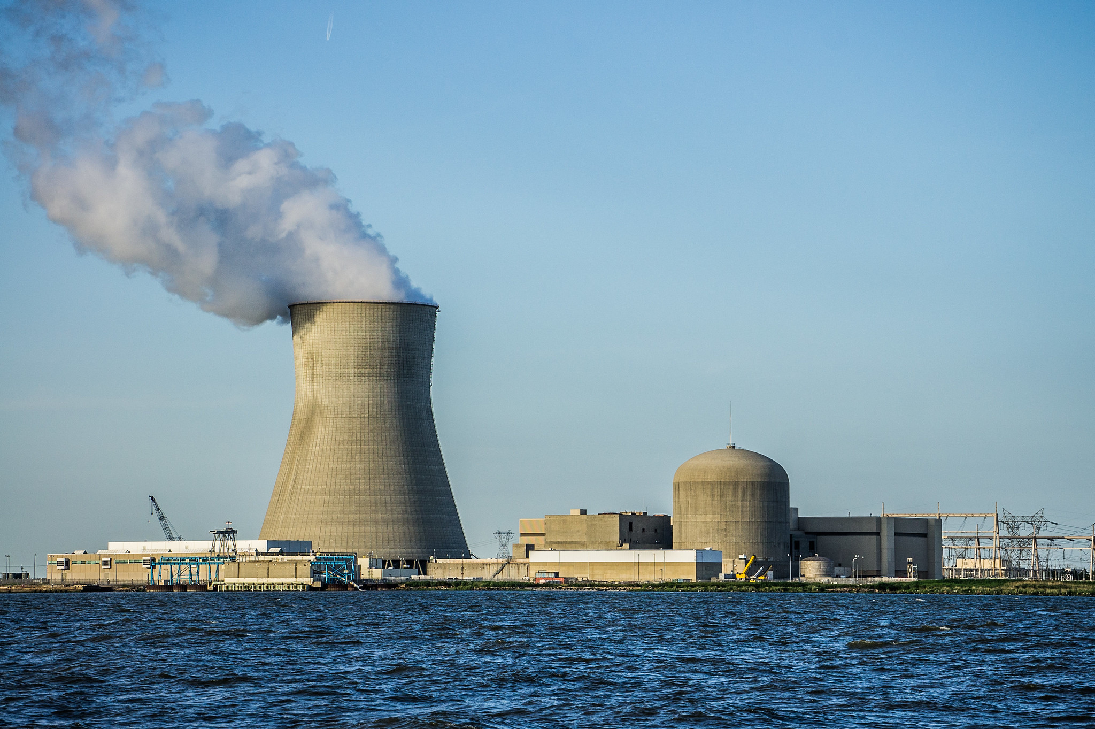

This assignment is a prototype for a nuclear reactor alarm. You will integrate and use everything you’ve learned by now to create an alarm.

### Requirements

1. Arduino Uno (or compatible)
2. Open-Smart Rich-shield
3. Arduino IDE

To complete this assignment you should understand and be able to apply the following techniques:

* Analog & Digital I/O
* Buttons, LEDs, LDR, NTC, Buzzer
* Prevent button bouncing
* Threshold & Hysteresis

### Introduction

For safety reasons the reactor has to be monitored for temperature and brightness. In the reactor an NTC is mounted at 2m height in the wall and an LDR is mounted at 8m at the top in the center. If the reactor temperature or brightness it outside the normal operating range, then something is wrong and an alarm should be triggered.

To make this alarm you are asked to build an embedded system with the following behaviour.

The system has two operating modes.

1. Temperature mode
2. Brightness mode

You can switch between these modes by pressing Key1 and Key2. Key1 enables temperature mode and Key2 enables Brightness mode. One mode can be active at a any time.

For both modes:

Whenever it gets too hot or too bright in the reactor the buzzer will start notifying the scientists that they have to take action.

Pick two leds that indicate which mode the system is in.

The alarm should sound like an alarm that pulses for 10 seconds. It should be possible to tell from the alarm which problem is occuring. I.e. the sound for a temperature problem should be different than the sound for a brightness problem.

It should be possible to switch between both modes at any given moment. This means that I can press a button even when the alarm is on.